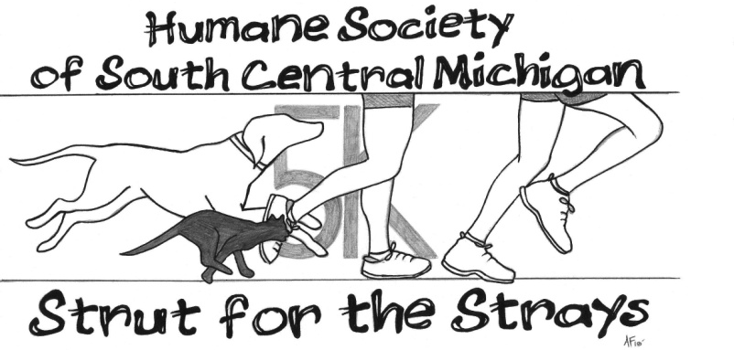
July 8th, 2023
Registration Form

Name:

Address: City: State: Zip:

Phone:

Email:

T-Shirt Size (Check One): S M L XL

I am under age 16: Age Day of Race: _________ Dog Participant $10 per dog

Please sign the waiver statement below: Dogs Name: ________________________

In consideration of this entry, being accepted, I hereby for myself, heirs, executers, and administrators waive and release any claims that I may have against the Humane Society of South Central Michigan or any of the sponsors involved in the 5k Strut for the Strays. I certify that I am physically able to participate in this event.

Name (under age 18 requires parental signature) Date

Thank you for your participation! Please make checks payable to HSSCM and mail them to the following address, pay online at our website, or call 269.963.1796, ext. 190 to pay by phone!
$30 per entrant Until July 1st- then $35 per entrant
Humane Society of South Central Michigan 2500 Watkins Road Battle Creek, MI 49015
www.hsscm.org

